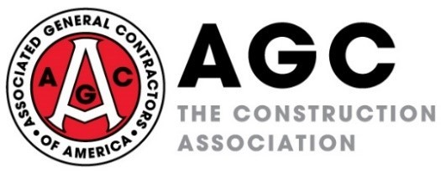

FOR IMMEDIATE RELEASE CONTACT: Brian Turmail

3/27/23 (703) 459-0238; brian.turmail@agc.org

Langston Construction of Piedmont, SC NAMED ONE OF NATION’S SAFEST CONSTRUCTION COMPANIES IN 2022 BY NATIONAL CONTRACTORS GROUP
Langston Construction Wins AGC-WTW Construction Safety Excellence Awards Second Place as 47 Other Companies Win Awards for Quality Construction Safety Programs
Langston Construction was recognized for having one of the nation’s top construction safety and health programs in 2022 by the Associated General Contractors of America (AGC). The association, which oversees the prestigious AGC-WTW Construction Safety Excellence Awards, an annual ranking of construction safety and health programs, noted that 47 other companies were also selected as winners for their commitment to safety and occupational health management and risk control.
“We invest so much time and energy in organizing what is a very rigorous awards program because this is a vehicle for elevating the safety and health of the industry” said Dan Fordice, the association’s president and vice-president of Fordice Construction Co. in Vicksburg, Mississippi. “By finding and highlighting some of the very best industry safety and health programs, we are seeking to elevate safety and health within the entire industry.”
Langston Construction was judged and selected as the second winner in the Utility Infrastructure division, under 200,000 work hours. Fordice noted that there are multiple winners because the awards are distributed for several divisions and categories, based on the amount and type of work performed. He added that the AGC-WTW Construction Safety Excellence Awards winners are selected by a panel of five independent safety and health professionals within the construction industry. “These firm developed and implemented exceptional safety and risk control programs through continuous improvement and maintenance of their safety and health management systems,” said Fordice. Finals judging for the awards program took place during the contractors’ association’s annual convention in Las Vegas, Nevada.
“WTW is proud to be a partner in safety with AGC by sponsoring the Construction Safety Excellence Awards. For over 30 years, this partnership has supported the construction industry by recognizing construction companies that go above and beyond minimum safety and risk control standards. These contractors are leaders in the construction community,” said Mike Fredebeil, CSP, Senior VP and Executive Director of Construction Safety and Risk Control, Willis Towers Watson.
View entire list of winners. View ceremony photos.
###

